PDC PG Client Scoping Document

Table of Contents

Section I 1

**Project Details** 1

**Introduction** 2

**Ask of PDC** 2

**Ways of Working** 2

**Project Type** 2

**Business Use Case** 2

**Success Criteria** 2

**High Level Architecture** 3

Section II 4

**PDC Environment** 4

**PDC Component List** 4

**PDC Infra Diagram** 5

**PDC Scope and Assumptions** 5

**Questions** 6

Section III 6

**User Provisioning** 6

# Section I

**Section I – Client Project Intake Form. To be filled in by the Client**

## **Project Details**

*Please provide project and contact details.*

|  |  |
| --- | --- |
| Project Name | UNAGI |
| RESPC / Business Line | Technical Offshore Wind |
| Business Sponsor | Jenneke Verhoef |
| ITM | Laura Duffey |
| Product Owner | Sun, Yin (Yin.Sun@shell.com) |
| Project Manager | Daryani, Pankaj K SITI-PTIY/CAB <P.Daryani@shell.com> |
| Technical Lead | TBD - assume someone from Bedros' team/ in combination with business rep. |
| Segment Architect | Zachariah, Jason (Jason.J.Zachariah@shell.com) |
| Solution Architect | Avinash.Kumar4@shell.com |
| Risk Management Lead | Kakkerla, Naresh [Naresh.Kakkerla@shell.com](mailto:Naresh.Kakkerla@shell.com) |
|  |  |
| Application ID | APM00603704 (UNAGI - Electrical System Concept Select Verification Tool) |
| WBS Code | TBC - budget request will be discussed with Sponsor Feb 3, finance process will take a couple of days to sort. |
| Cost Center Code | TBC - budget request will be discussed with Sponsor Feb 3, finance process will take a couple of days to sort |
| Estimated Budget ($) | 200K |
| Project Charter Link | https://eu001-sp.shell.com/:p:/r/sites/UGPTUNAGIprojectteam/Shared%20Documents/General/Electrical%20System%20Concept%20Select%20verification%20Tool%20charter.pptx?d=w1045a6d0de6c422eb9563a5149a95e50&csf=1&web=1&e=DL99Qg |
| Project Start Date | 31-01-2022 |
| Expected End Date | 30-06-2022 |

## **Introduction**

UNAGI is a Python based tool that performs design calculations and design verifications studies, to accelerate the electrical design and verification process for building new offshore windfarms. UNAGI is a specialist tool, used by a small number of electrical engineers in the offshore wind team. (<50 users)

They use UNAGI to conduct different types of studies to help identify and assess opportunities for future windfarm locations. Example studies include:

* What are the losses of the electrical cable throughout the lifetime of the windfarm?
* What are the critical limits of the windfarm in relation to the grid (overvoltage/undervoltage)?
* What is the capacity of the power cable given the distance of the windfarm from the shore?

UNAGI generates an output document using Latex.

## **Ask of PDC**

**Business expectations:**

* Currently, a first version of UNAGI has been developed by a business team as a desktop tool. To help distribute the tool efficiently across the other electrical engineers, redevelopment as a webservice is desirable with the PDC (AWS@Shell)

## **Ways of Working**

*Please tell us how you would like to work together? Knowing your preference will allow us to align before diving in.*

|  |  |
| --- | --- |
| X |  |
|  | *Give me a platform for my team to develop on – we are good on our own* |
|  | *Give me a platform and train/guide/assist my team as they come up to speed and implement* |
| X | *Work with my team to jointly implement the project* |
|  | *Do it for me* |
|  | *Something else – please describe* |

## **Project Type**

*Please tell us the type of your project. This will help us propose the right environment for you.*

|  |  |
| --- | --- |
| X |  |
|  | *Spike / Trial – we want to test the capability of a specific single technology component* |
|  | *POC / Prototype – we want to prove a product or custom solution implementation (business use case or/and an end-to-end technical flow)* |
| X | *MVP / Production – we want to take it to production as part of this project scope* |
|  | *Something else – please describe* |

…

## **Solution Type**

*Please tell us the type of solution you are building. Pick all that apply.*

|  |  |
| --- | --- |
| X |  |
|  | *Lift & shift legacy application - maintain an operational mode, no refactoring* |
|  | *Data Engineering – data centric ETL workflows with multiple data sources, analytical dashboards* |
| X | *Custom cloud-native development - microservices based* ***Shell Internal*** *consumer-facing (i.e. web app, mobile app)* |
|  | *IOT - Asset analytics and asset control* |
| X | *~~ML/AI/~~Data Science centric application* |
|  | *Something else – please describe* |

## **Business Use Case**

Having the tool in a global compliant Shell platform (PDC) that also has the processing power to run the simulations very fast, will increase the efficiency of the engineers working on the electrical design.

As this is a specialized tool, the number of users will not be very big – at most around 50 users. However, the impact to their efficiency and effectiveness is likely to be very big.

Based on the information we have at this stage, the 5-year NPV for this project should be in the range of 500k to 1m USD

## **Success Criteria**

We need a place on PDC (power digital core) to run the Python tool (Unagi) so that other users have access to it. A (business) consultant has been redeveloping UNAGI as a web application, which now needs to be deployed in the PDC environment. This would remove the effort required to deploy the application as desktop (developer rights etc), as well as help with an environment that has the ability to scale compute power when large studies need to be run, and scaled back when not in use.

The scope of this project also includes addressing the minimum required assurance in terms of IRM, Architecture and Operations.

The scope does not include hosting other simulation software on PDC, and making it easier to connect to this simulation software from UNAGI. This will be scoped as a separate project iteration, subject to business demand and funding.

## **High Level Architecture**

*Please provide a high-level architecture diagram representing the agreed solution for the project.*

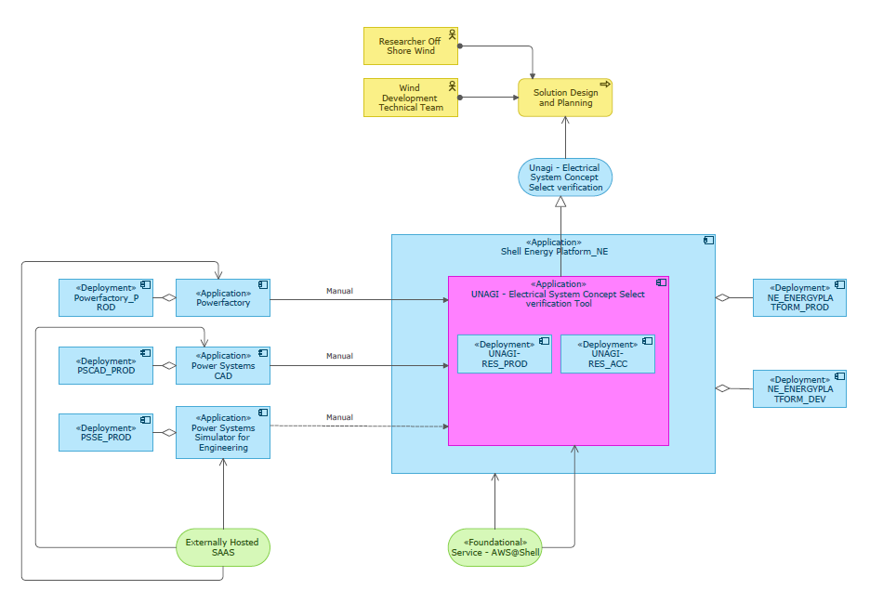

# Section II

**Section II – To be filled in by Solution Delivery Tech Lead. This section can be implemented in MSForms and integrated with ServiceNow and Jira.**

## **PDC Environment**

*Please select the environment required for the project*

|  |  |  |
| --- | --- | --- |
| **Project Type** | **Environment** | **Required** |
| Trial / Spike | PDC Sandbox (Hub) | [ ] |
| POC / Prototype | PDC Multitenant  AWS@Shell Isolated | [ ]  [ ] |
| MVP / Production | AWS@Shell Isolated | [x] |

## **PDC Component List**

*Please tick components required according to capabilities*

|  |  |  |  |
| --- | --- | --- | --- |
| **COMPONENT** | **AWS 1.0**  **(PDC Multitenant)** | **AWS 2.0**  **(AWS@SHELL)** | **Required** |
| AWS Authentication  Dev Tools Authentication  Customer Facing (internal)  Customer Facing (external)  Single IP Whitelisting | IAM  GitLab  PingID  Janrain  VPN | PingID SSO  Ping ID (Port / TBC)  PingID  Akamai  VPN | [x]  [ ]  [x]  [ ]  [ ] |
| Containerization | EKS | EKS | [ ] |
| CI/CD  Infrastructure  Application | GitLab + Terraform (Open Source)  GitLab | Terraform Enterprise +  Terraform + Github  GitHub | [ ]  [ ]  [x] |
| Source Code Management (SCM) | GitLab | GitHub | [x] |
| Workbenches & SDK | JupyterLab  VS Code | JupyterLab  VS Code | [ ]  [x] |
| Data Lake Storage | S3 | S3 | [x] |
| DB Storage | PostgresDB (RDS)  PosrgresDB (TSDB) | PostgresDB (RDS)  PostgressDB (TSDB) | [ ]  [ ] |
| Machine Learning | KubeFlow (Arrikto) | Kubeflow (Arrikto) | [ ] |
| ETL | Airflow (PDC-managed) | Airflow (AWS-managed) | [ ] |
| Data Virtualisation | Dremio | Dremio | [ ] |
| Data Service API | GraphQL  Hasura | GraphQL  Hasura | [ ]  [ ] |
| API Gateway | Mulesoft | Mulesoft | [ ] |
| Certifications | Cyber Essentials  Shell IT Controls | Shell IT Controls | [ ]  [x] |

## **PDC Infra Diagram**

*Please provide PDC Infrastructure and Networking diagram for provisioning.*



## **PDC Scope and Assumptions**

**In Scope**

*Please provide a high-level WBS for the project. Line items should be easily translatable into user stories for PDC. Examples: validate user connectivity to Shell, establish connectivity to xxx data source, setup data ingestion pipeline, etc.)*

* We need a place on PDC to run the Python tool (Unagi) so that other users have access to it. We would need a specialist who can look at the code, review it, and potentially make modifications to make it work on the PDC. It is built on Pythion Tkinter at the moment. Should be re-built with Python Dash.
* We need another server that can host the specialized software, like the PSCAD or DigSilent Power Factory. They need to be installed on a machine which should have multiple cores to do calculations.
* Ultimately, we would need an interface that will allow Unagi to call the specialized software, give it the calculations it needs to perform, and get the results back.

**Out of Scope**

*Please specify what will not be done by PDC. Think of this as demarcating the boundaries of PDC scope related to functionality, data, IRM, performance tuning, etc. Include anything that PDC is not accountable and/or responsible for, regardless if in scope for the client. This helps avoid scope creep during the initiative.*

**Assumptions**

*Please identify PDC assumptions related to client responsibilities/WoW and on the technology solution. Examples: BIA is the responsibility of the client team.*

* PIRA, BIA, LRA to be done by Project team
* The python code for UNAGI has already been developed and it needs to be deployed as a web-based application in PDC
* To be added …

## **Questions**

*Please list any open questions which might impact the scope.*

* …
* …
* …

# Section III

**Section III – To be filled in by the Client. This section can be implemented in MSForms and integrated with ServiceNow and Jira.**

## **User Provisioning**

*Please provide a list of users that require access to the resources (development team only, excluding end users). Assumption is to provide access to all resources unless differently specified. Please use field ‘remarks’ for details.*

|  |  |  |  |
| --- | --- | --- | --- |
| **First Name** | **Surname** | **Email** | **Remarks** |
| Yin | Sun | Yin.Sun@shell.com |  |
| Avinash | Kumar | Avinash.kumar4@shell.com |  |
|  |  |  |  |
|  |  |  |  |
|  |  |  |  |
|  |  |  |  |
|  |  |  |  |
|  |  |  |  |
|  |  |  |  |
|  |  |  |  |
|  |  |  |  |
|  |  |  |  |
|  |  |  |  |